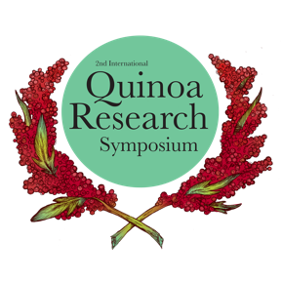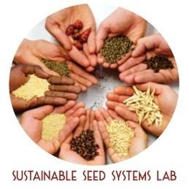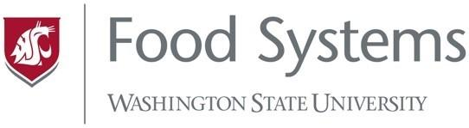

FOR IMMEDIATE RELEASE
Contact: Aba Kiser (WSU Food Systems)
121 Oak Bay Road,
Port Hadlock, WA 98339
360-379-5610 ext 211

International Online Quinoa Research Symposium Shares Breaking Research, Indigenous Knowledge, Community.
Hundreds tune in live from 52 countries for three days of bi-lingual interactive keynotes, field walks, poster sessions, and discussion forums to focus world attention on the role that quinoa plays in contributing to food security, human health and nutrition, sustainable production, and holistic use worldwide.

(Worldwide) The Washington State University Sustainable Seed Systems Lab (SSSL), in collaboration with the WSU Food Systems Program co-produced the 2nd International Quinoa Research Symposium (IQRS) August 17-19, 2020, a bilingual online event utilizing interactive virtual platforms to showcase diverse research presentations with leading experts worldwide.

“The objective of the IQRS was to focus world attention on the role that quinoa plays in contributing to food security, human health and nutrition, sustainable production, and holistic use worldwide,” said Dr. Kevin Murphy, Associate Professor at WSU and IQRS co-organizer.

This event presented a valuable and unique opportunity to network, engage, and learn from fellow quinoa enthusiasts on an international stage. The program included a recorded field walk with the Organic Seed Alliance, an informative Zine with quinoa recipes made in collaboration with QuinoaLab (Chile) and the Culinary Breeding Network, an interactive poster session with 35 presenters lead by Julianne Kellogg, interactive discussion forums, and 26 research sessions from leading experts in their fields on a wide range of topics including agronomy, phenotyping, ancestral knowledge, and market uses.

“The 2020 Symposium was the 7-year-long-awaited ‘encore’ by quinoa supporters world-wide.” said Sergio Nuñez de Arco of Ardent Mills (formerly Andean Naturals). “Much like its 2013 predecessor, this unique event assembled a multitude of professionals. During 3 days professors, students, marketers, food scientists, geneticists, agronomists, processors, family farmers and agro-industrial growers shared their passion around quinoa. We all believe that this pseudo-grain has a big part to play in alleviating poverty, providing food security and boosting nutrition. The Quinoa Symposium helped bring quinoa one step closer to regaining its status as an staple—an every-day food.”

At the Symposium
939 Registrants from 52 countries registered for this bi-lingal event, with the largest contingencies from the United States (20.8%), Perú (14.2%), Bolivia (12.5%), Chile (10.2%), and Ecuador (6.8%). The largest professional sectors represented in registration were Researchers (32.3%), Academics (21.2%) and Farmers (13%). Farmers shared quinoa production techniques and centuries-old indigenous wisdom on growing quinoa in its native regions. Scientists and researchers reported on cutting-edge findings, identifying gaps in knowledge, and establishing working relationships to advance quinoa research and development. A little over half of all attendees utilized the Spanish registration (51%) with English speakers registering at a rate of 49%.

Impact
- 51 speakers and 35 poster participants in 26 sessions presented in both Spanish and English over three days, including interactive sessions, field walks, lightning talks, and discussion forums.
- 96% of attendees felt that the organizers met their need for an online event, with 87% also reporting satisfaction with networking and participant interaction. 75% of attendees participated in all three days, pointing to the efficacy of the online event as a community building experience.
- Over 30% of attendees listed sharing their research as the main reason for attending, pointing to the large expertise among participants. Nearly 20% listed networking as their primary reason for attending, demonstrating worldwide community enthusiasm for quinoa’s potential and the need to develop relationships across sectors.
- 6021 collective Youtube Views of all Symposium material on the Sustainable Seed Systems Lab channel: tinyurl.com/seedsystemsyoutube, including 1072 views of Day 1 of the live symposium.
- 296 members in the online networking platform Slack, with 3250 messages sent between members throughout the event.

Funding
This event was offered for free online thanks to the USDA-OREI Organic Research & Extension Initiative Project #2016-51300-25808, the WSU Center for Sustaining Agriculture and Natural Resources (BIOAg grant) and the generous support of sponsors, including The Annex by Ardent Mills, QuinoaLab, Jiaqi Quinoa Breeding, Algosur, Andean Naturals and Lundberg Family Farms.

More information on WSU Sustainable Seed Systems Lab The WSU Sustainable Seed Systems Lab is a group of plant breeders, researchers, and graduate students set on a path to bring diversity to agro ecological landscapes through innovative plant breeding and agronomic practices. Local farmers inspire research projects and supporters and funders fuel their pursuit of adapting novel crops to specific regions and developing new, functional traits for staple grains. They partner with farmers throughout the Pacific Northwest to conduct variety, agronomic, and breeding trials on their land. The Sustainable Seed Systems Lab emphasizes the value of engaging farmers throughout the breeding process, melding of farmer and researcher knowledge. www.sustainableseedsystems.org/

More information on the WSU Food Systems Program The Washington State University Food Systems Program delivers multidisciplinary expertise across academic, research, and extension, providing specialized resources for farmers and food systems contributors. They work with communities throughout the state to foster viable farm businesses, optimize sustainable natural resource stewardship, and promote scaled processing and distribution, always in the pursuit of access to healthy food for all. foodsystems.wsu.edu/
For more information visit www.quinoasymposium.com.
@sustainableseedsystemslab @wsufoodsystems #iqrs #iqrs2020
Contact: Aba Kiser (WSU Food Systems Communications Coordinator)
aba.kiser@wsu.edu or 360-379-5610 ext 211

